Task 3 Cybersecurity Bootcamp X OWASP

By Sunny Abraham Mathew

1.Does the target ip respond to ICMP echo (ping) requests (Y/N)?

No ,it was saying host was down.

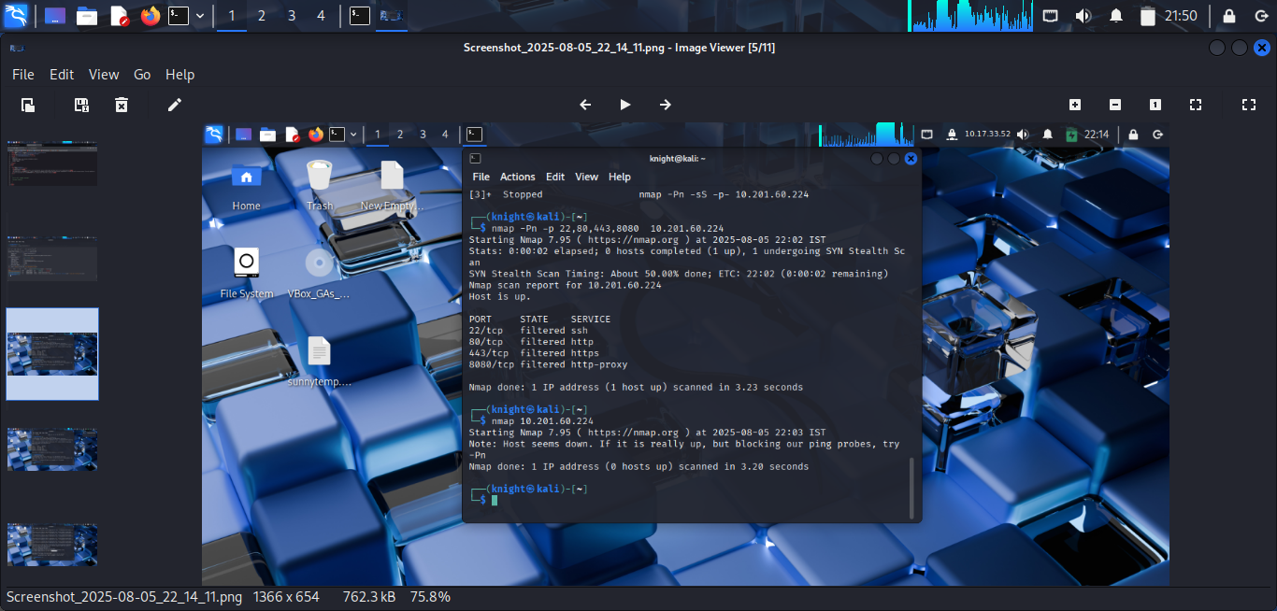

2. Perform an Xmas scan on the first 999 ports of the target -- how many ports are shown to be open or filtered?

999 ports were filtered and it showed no response

3. Perform a TCP SYN scan on the first 5000 ports of the target -- how many ports are shown to be open?

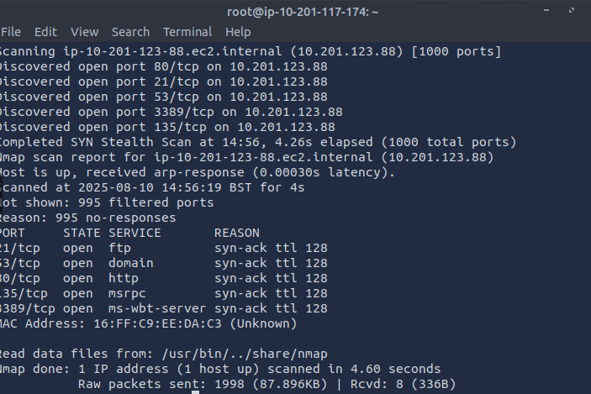

4. Open Wireshark (see [Cryillic's](https://tryhackme.com/p/Cryillic) [Wireshark Room](https://tryhackme.com/room/wireshark) for instructions) and perform a TCP Connect scan against port 80 on the target, monitoring the results. Make sure you understand what's going on. Deploy the ftp-anon script against the box. Can Nmap login successfully to the FTP server on port 21? (Y/N)

Y

